|  |  |  |  |
| --- | --- | --- | --- |
| VERSION HISTORY | | | |
| **Revision No** | Revision Date | **Description of Changes** | Author |
| 00 | 19.08.2021 | First Release | Naime DAMATAŞI |
| 01 | 27.08.2021 | Format adaptation, Added some extra info, Added Wordpress Multilingual Prefenceres | Mehmet DURMAZ |
| 02 | 02.11.2021 | Test clause added | Mehmet DURMAZ |
| 03 | 20.12.2021 | Database optimization section added | Mehmet DURMAZ |
|  |  |  |  |
|  |  |  |  |
|  |  |  |  |
|  |  |  |  |
|  |  |  |  |
|  |  |  |  |
|  |  |  |  |
|  |  |  |  |
|  |  |  |  |
|  |  |  |  |
|  |  |  |  |
|  |  |  |  |
|  |  |  |  |
|  |  |  |  |
|  |  |  |  |
|  |  |  |  |

# PURPOSE

This document aims to explain how to input products in wordpress which is in multisite establishment.

# SCOPE & RESPONSIBILITIES

All product input activies in Wordpress Backend are covered under this document. All staff associated with the adding product activities are to comply with the requirement of this document.

# DESCRIPTIONS

# PROCEDURE

## Critical information

The following information is required before a new product is entered:

1. Name of product
2. Vendor
3. SKU
4. Price
5. Short Description for frontend
6. Intrastat code
7. Tax Class of Product (standard or reduced)
8. Number of boxes on a pallet
9. Pallet type sent by vendor of product
10. Product Box Weight:
11. Product Box Dimensions (width, length, height)
12. Packing specs (Unit quantity in box X Unit weight/liter(
13. Product type (Generic short description of product)
14. Packing type (Unit packing spec: pet / glass / tetrapack vs.)
15. Ingredient (Product’s main ingredient)
16. Shelf-life of Product in months

## Login

For initial product input, it is required to login to the admin panel of the main site. The generic address schema is given: https://{domain}/admin.

If subject is an e-commercing site in wordpress network mode, access main site select main site form the **“My Sites”>Site>Dashboard** menu:

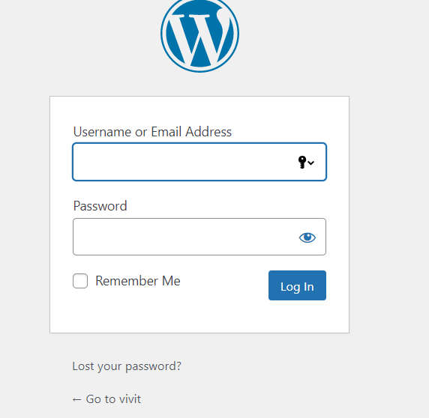 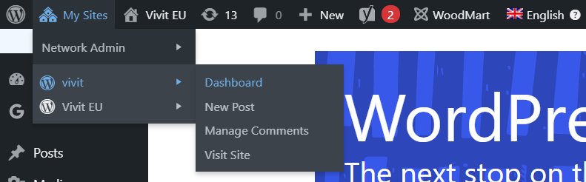

## Product Menu

Product menu can be found under WooCommerce at the admin panel of main web site. Add New is sub menu of Product as shown below:

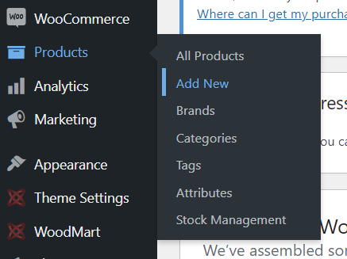

## New Product Page

In this page first metabox is the place for product name

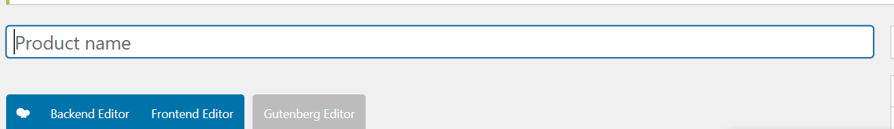

The following metabox is available to enter the main details of the product:

## Product data (type) Metabox00

Product Type is for defining how this product should be represented and handled via woocommerce system

Simple Product is a single formed product

Variable Product is a product which variate via some attribute like color, size vs.

Other options are not the subject of the procedure. In the following, the necessary fields are specified under the headings:

### General:

Regular price, Tax Status (taxable), Tax Class

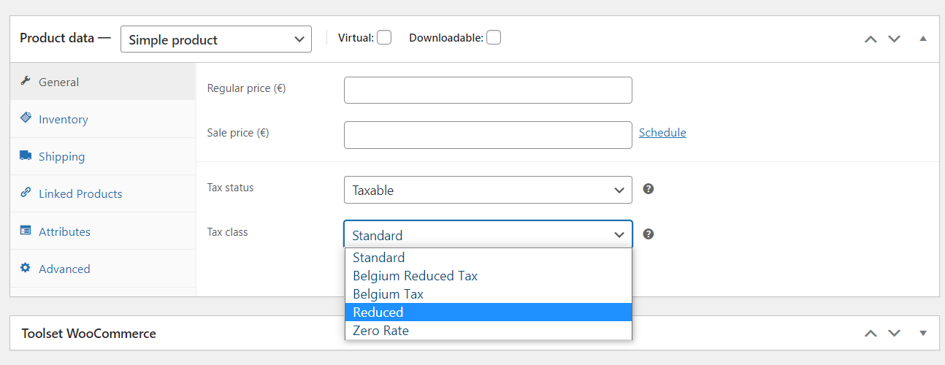

### Inventory:

SKU is critical info. If product has a stock information, check Manage stock and enter Stock quantity. Also select if backorder of product is available or not.

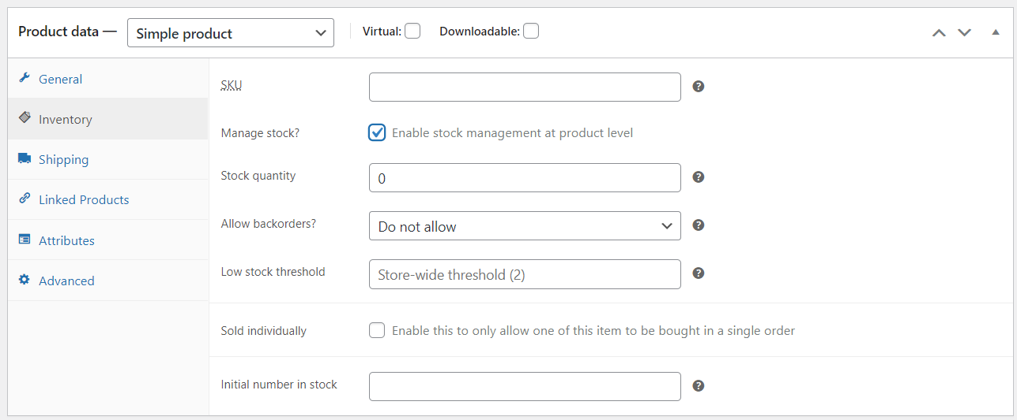

### Shipping;

Weight(kg), Dimensions(cm) (unit or box dimension. Depends how it is on sale). This information is critical since some calculation functions depends on those values.

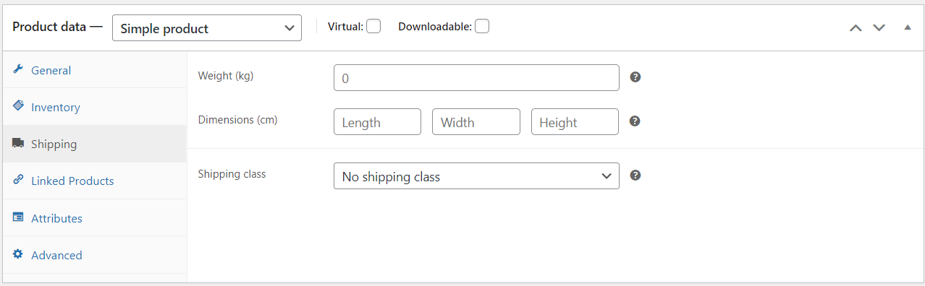

### Attributes;

Everyattributes are needs to be set in order to make it able to filter products, inform customer and support some functionality depends on those values.

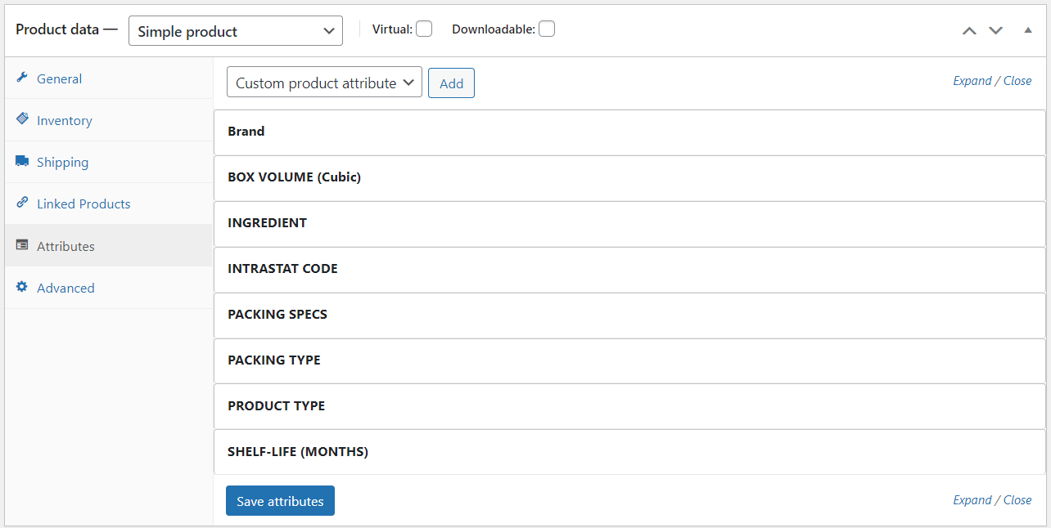

### Product Category and Brand Metaboxes

Those information should be chosen carefully in order to show product in right place in website.

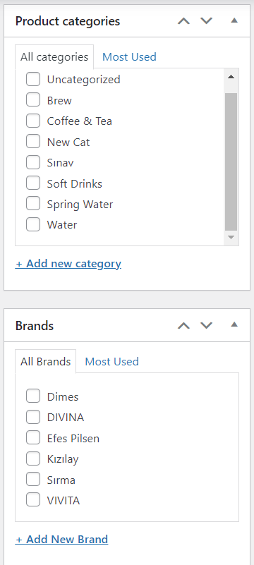 

### Product Short Description Metabox

This metabox stands for entering a short description and is text that will be displayed on the frontend that informs and impresses customers.

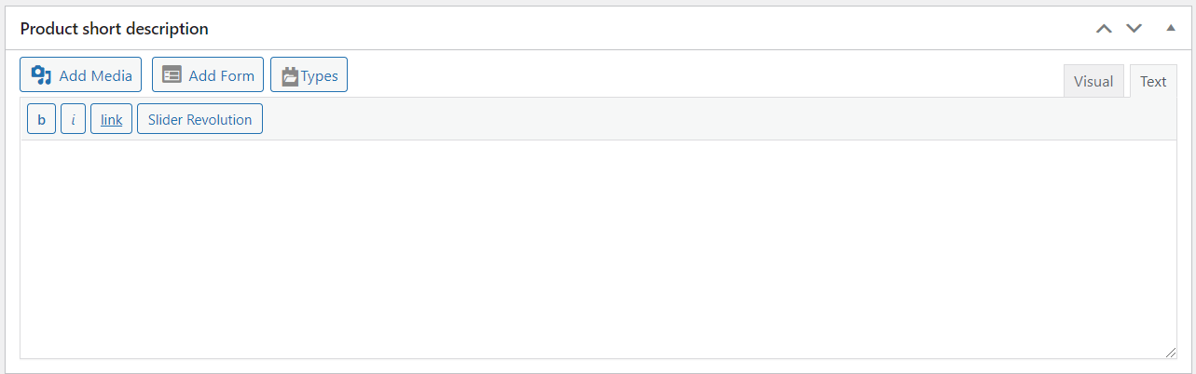

### Product Gallery

Select a suitable image. In terms of SEO, please be careful when naming the image file.

### Product Tags

Select tags for products in terms of SEO. It can also be accomplished later.

## Transfering changes to other subdomains

If subject e-commercing site not in wordpress network mode, every change should passed to other domain. To accomplish this section must be applied after every entry or update.

### Transfering Products to Subdomains

Each subdomain is represented by the meta box labeled “translation of xxxxxxx” as the title. To import a product into other subdomains, each subsequent metaboxes provided by **“Wordpress Multilingual Plugin”** must be handled properly.

### Relationship

If the product is not preferred to be transferred to a subdomain, "Keep Not Connected" can be selected.

If the product is preferred to be transferred to a subdomain, "Create a new…" can be selected

If the product is already known to reside on another domain, “Select an exisiting…” can be selected

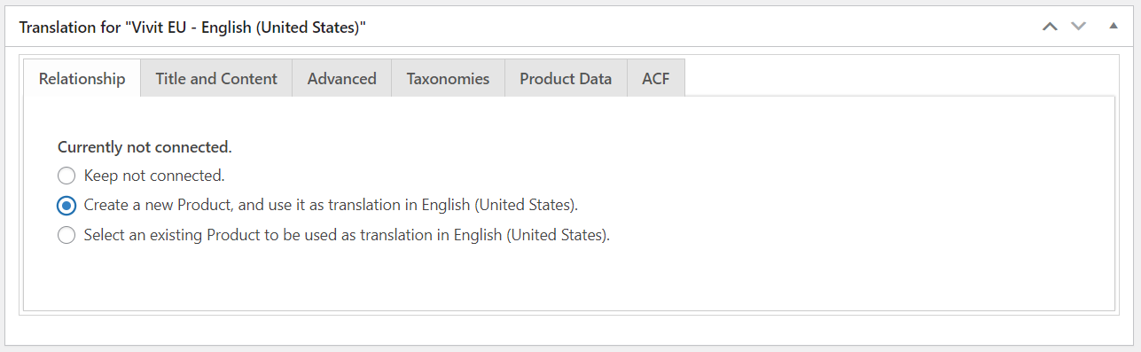

### Title And Content

Warning: The auto-generating of this field has been proven to fail. So New Post Title must be entered

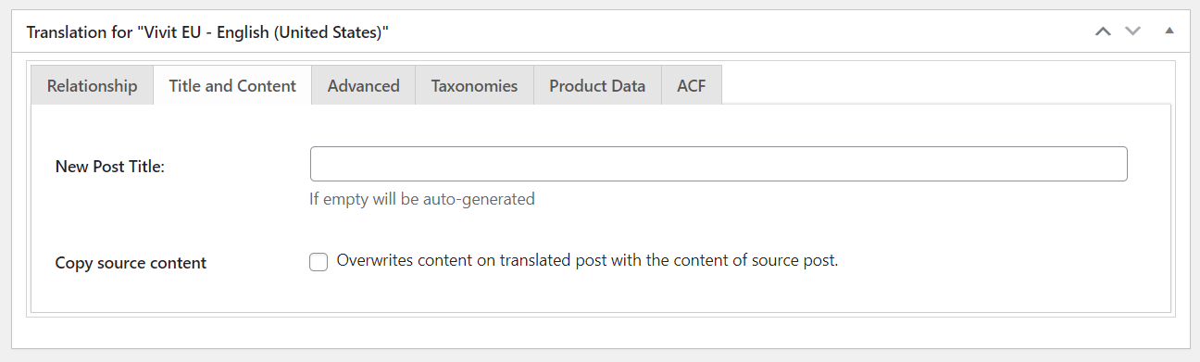

### Advanced;

New Post Slug should left empty.

New Post Status: Select same status as for new product

Check checkbox labelled as “**Overwrites the target post….”** checkbox.

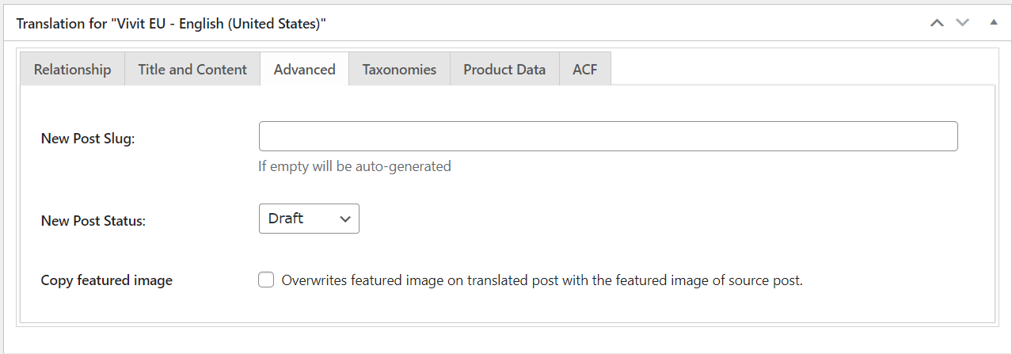

### Taxonomies

Check the **Synchronize Taxonomies** checkbox.

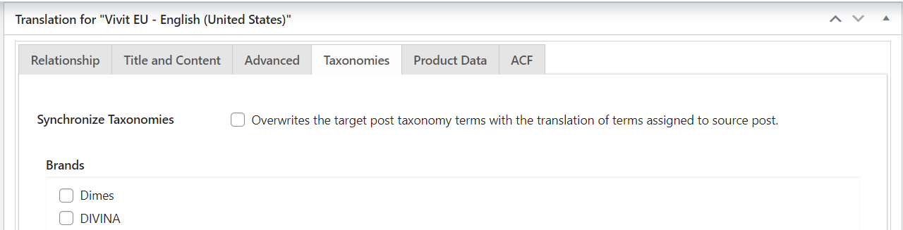

### Product Data;

#### General

Enter a suitable price for your subdomain

#### Inventory

In this section entering same SKU is essential for building relationship between same product in different domains

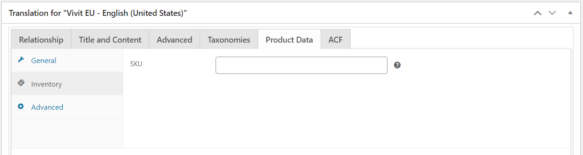

For product type, Attribute, Gallery, etc. just check the checkboxes.

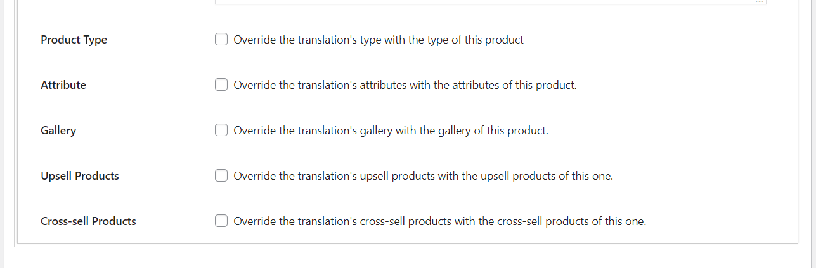

### ACF

Check “Copy ACF Fields”

## Organizing Database

After mass product addition, category organization woocommerce toosl should be executed stated at woocommerce -> status -> tools. Please use them step by step and watch them in scheduled actions and wait for them processs finalizing before running other one.

**Expired transients** This tool will clear ALL expired transients from WordPress.

**Product lookup tables**

**Regenerate the product attributes lookup table   
Orphaned variations**

**Product lookup tables**

# TEST

Test trials for the described studies should be conducted on the transition site rather than the live site. For this activity, the same copy site in the staging subdomain can be used instead of www;

[www.hotcoldshop.com](http://www.hotcoldshop.com) -> staging.hotcoldshop.com

[www.vivit.bio](http://www.vivit.bio) -> staging.vivit.bio

[www.vivit.bio/bhs](http://www.vivit.bio/bhs) -> staging.vivit.bio/bhs

# REFERENCES

Wooocommerce Multilingual Documentation: https://docs.woocommerce.com/document/woocommerce-multilingualpress